Have you ever really thought about what it is like to walk in someone else's shoes?
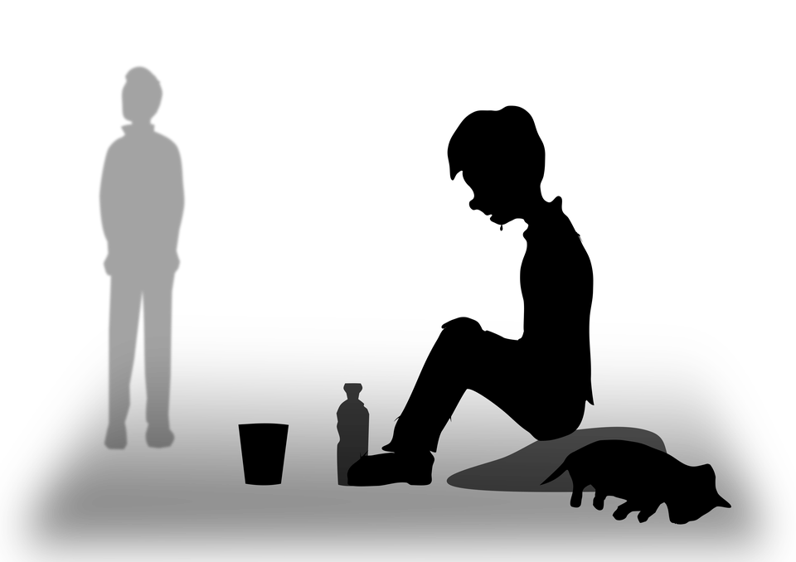
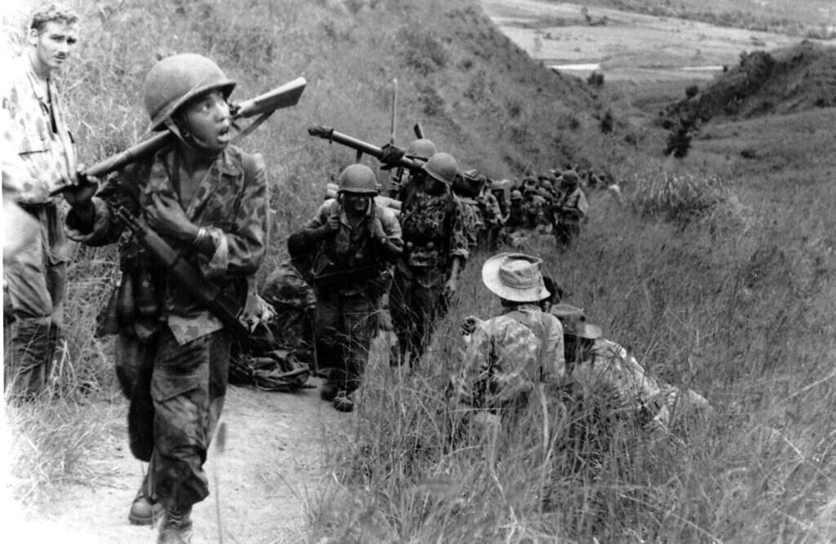
I have thought about walking in someone else’s shoes at various times because I have thought about the people of Ukraine and how sad they must be, homeless, penniless and starving. Speaking of that, I have also been in Chelmsford and seen homeless people. I have thought about the families with stillbirth babies too.

I have helped these people too.
Ukraine people- I have made loom band bracelets and sold them and made £110+.
Homeless people- We gave money to a Homeless man who was asking for money so he could go to a shelter for the night.
Stillbirth families- I raised money by doing 10,000 steps a day for a week for Sands.
By Isabelle Lauder yr5

